**DAILY ONLINE ACTIVITIES SUMMARY**

|  |  |  |  |  |  |  |  |  |
| --- | --- | --- | --- | --- | --- | --- | --- | --- |
| **Date:** | **27/05/2020** | | | | | **Name:** | **Prashant Rama Bhat Kodlekere** | |
| **Sem & Sec** | **4th sem (B sec)** | | | | | **USN:** | **4AL18CS060** | |
| **Online Test Summary** | | | | | | | | |
| **Subject** | | **Object oriented concepts (OOC)** | | | | | | |
| **Max. Marks** | | **30** | | **Score** | | | **27** | |
| **Certification Course Summary** | | | | | | | | |
| **Course** | **Python3 for bigginers in 2020** | | | | | | | |
| **Certificate Provider** | | | **Udemy** | | **Duration** | | | 3 sessions |
| **Coding Challenges** | | | | | | | | |
| **Problem Statement :** Write a C Program to sort an array of integers in ascending order and display the sorted array and Number of passes performed for sorting.  Top of Form  Bottom of Form | | | | | | | | |
| **Status:Completed** | | | | | | | | |
| **Uploaded the report in Github** | | | | | **YES** | | | |
| **If yes Repository name** | | | | | **https://github.com/prashantkodlekere/codingactivity** | | | |
| **Uploaded the report in slack** | | | | | **YES** | | | |

Online Test Details:

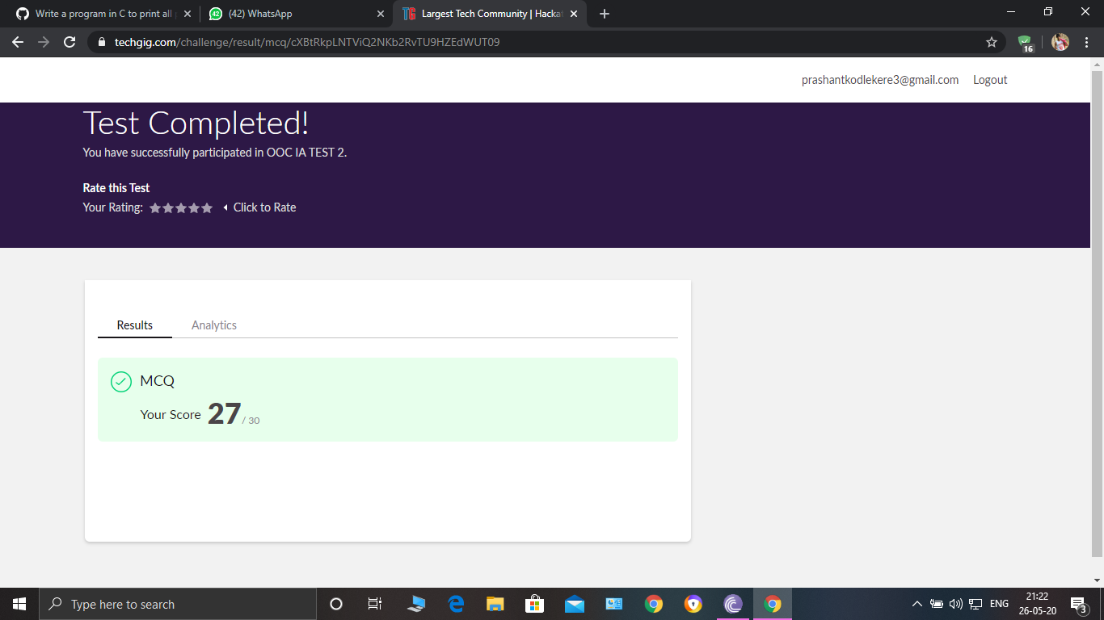

Objest oriented concepts(OOC) Internals was conducted. A total of 30 questions were Multiple Choice Questions.

The above snapshot is the result sheet which was mailed to us by the Techgig team.

Certification Course Details:

Course name : Python3 for bigginers in 2020(1st ,2nd and 3rd session)

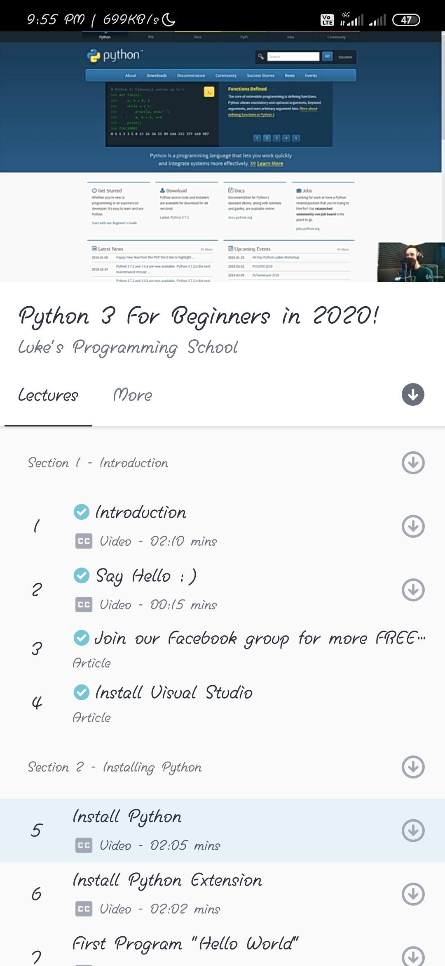

In session 1,I have learnt the introduction to this new course which I have took. And process to install virtual studio.

In session 2,I have learnt to install python and python extension and hello world program.

In session3, I have learnt about variables and starting of operations

Iin Coding Challenges Details:

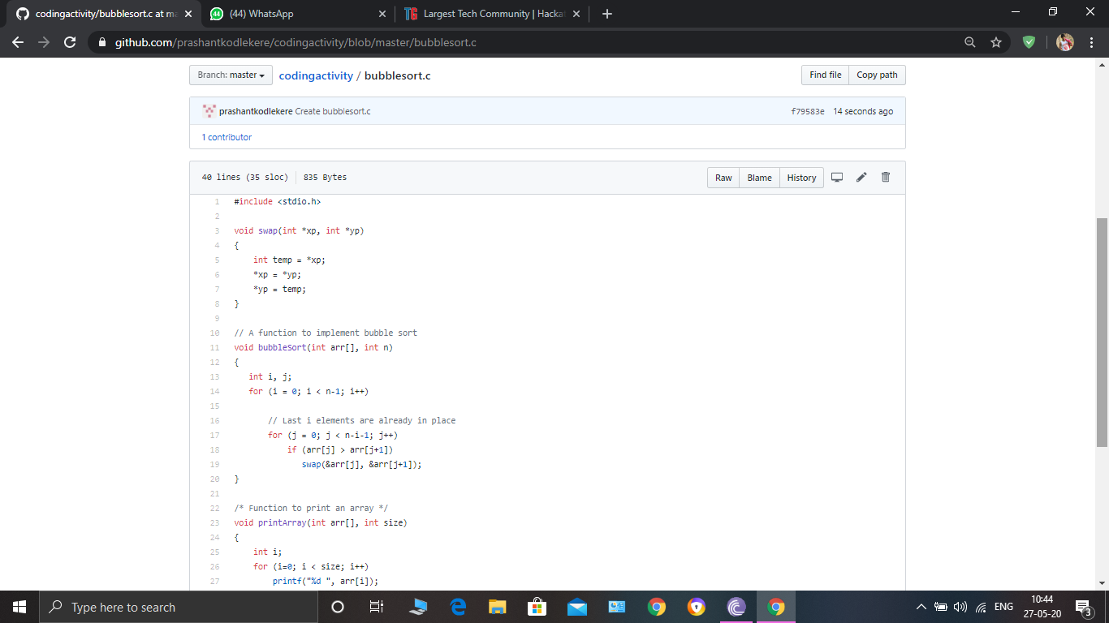

**The question I took to code is:**

Write a C Program to sort an array of integers in ascending order and display the sorted array and Number of passes performed for sorting.

Code: The above snapshot is the code which I have uploaded in my Github repository.